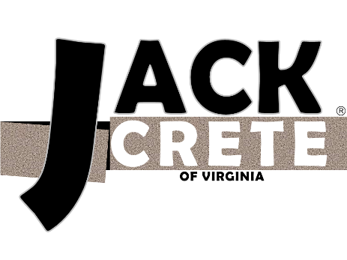

JACKCRETE, Hampton Roads premier concrete lifting and leveling company, is seeking a regional relationship manager with an interest in construction to join our team. Our aggressive expansion means ample opportunity for growth and you do not need a background in concrete lifting to join us. If you are highly motivated, excel at meeting new people, and are a proven multi-tasker this will be the ideal position for you.
Job Brief:
The regional relationship manager position requires you to introduce JACKCRETE’s service to prospective clients in the large-scale commercial and government sectors using a variety of methods. Present at trade shows, chat at networking events, attend conferences, peruse professional social media and online professional forums; use any means available to build relationships with the people that could benefit from our service. After a connection is made, the ideal candidate will be willing to follow up regularly and go the extra mile to ensure a prospect is converted into a client.
Responsibilities:
- Research opportunities for company promotion (tradeshows, networking events, professional organizations, etc.)
- Attend different industry and professional events for different associations, working to build relationships with prospects
- Manage company involvement in professional associations such as VAMA, HRUHCA, HRACRE, AGC, and ABC
- Leverage all available resources to introduce JACKCRETE to new prospects. Includes personal connections, fellow association members, connection referrals, LinkedIn research, etc.
- Follow up with prospects and nurture relationships
Requirements:
Success in this position will be based on your ability to work closely with type-A coworkers with high standards. This is a fast-paced role that requires exceptional multi-tasking skills and time management skills.
- Bachelor’s degree (or comparable experience)
- Friendly, outgoing personality
- Ability to work occasional weekends/long days as required by networking events and tradeshows
- Ability to travel as needed
- Strong organization and planning skills
- Ability to pick up new things quickly and adapt to new situations
About Us:
JACKCRETE, a division of RPC Industries, Inc., specializes in commercial, municipal, and residential polyurethane foam concrete lifting, leveling, and stabilization. Our non-disruptive procedure typically takes less than half a day, is cured and ready for vehicle traffic in just 15 minutes, and typically costs half that of concrete replacement. Learn more about our company and process at www.JackcreteVA.com. Enjoy working at a company with the excitement of a start-up culture while being backed by the security of a 37-year old industrial and commercial contracting leader. Our parent company specializes in industrial and government contracting specifically in roofing and insulation, asbestos and lead abatement, and a wide spectrum of applications with sprayed polyurethane foam since 1979.
Benefits:
At JACKCRETE, we provide an exciting, challenging, and fun working environment with plenty of opportunities to expand your career. We encourage continual training and promote from within. You will enjoy working alongside other talented people within an organization that takes pride in what we do! Additional benefits include:
- Competitive salary
- W2 Employee status
- Medical, dental, and vision insurance
- Simple IRA savings plan with company match
- Life and long-term disability insurance coverage
- Paid time off
- Paid holidays
Location: Hampton, VA
Hours: Monday-Friday, 8 :00am-4:30pm

